|  |
| --- |
| Studybank |
| Studybank API for BeNative |
| Description and study history |
|  |
| **Anderson** |
| **2015/5/14** |

|  |
| --- |
| StudyBank To BeNative 系統串接 |

|  |  |
| --- | --- |
| Project | BeNative 系統串接 |
| Team | 技術研發 |
| Document Title | Studybank API for BeNative |
| Document Class | Requirements |

|  |  |  |
| --- | --- | --- |
| Revision | v 1.0 | |
| Author | Anderson | |
| Date | 2015/05/14 | |
| Revision History | v 1.0 | First Release |
|  |  |  |
|  |  |  |
|  |  |  |
|  |  |  |
|  |  |  |
|  |  |  |
|  |  |  |
|  |  |  |
|  |  |  |
|  |  |  |
|  |  |  |
|  |  |  |
| Notes : | | |

**基本規則**

1. 使用者在StudyBank註冊並透過手機認證成為會員後，登入StudyBank即可購買BeNative課程。
2. 會員購買了BeNative課程後，將會在StudyBank網站MyRoom功能裡找到所購買過的課程列表。
3. 會員在MyRoom的課程列表裡BeNative課程點選後，將會透過StudyBank API帶入會員在StudyBank所購買的BeNative所有課程資料及會員資料HTTP Request的POST method導向BeNative端。
4. 會員將會在BeNative進行課程服務。

**注意事項**

1. 因為所帶資訊具有會員個人資料，所以採取資料加密動作(DES)。
2. 加密函式及範例將另外提供。

**相關程式路徑參考**

* 单点登陆DES加密算法API（PHP版）

**http://www.uyan.cc/help/html/des-api**

**http://blog.csdn.net/clh604/article/details/20228159**

**操作流程參考**

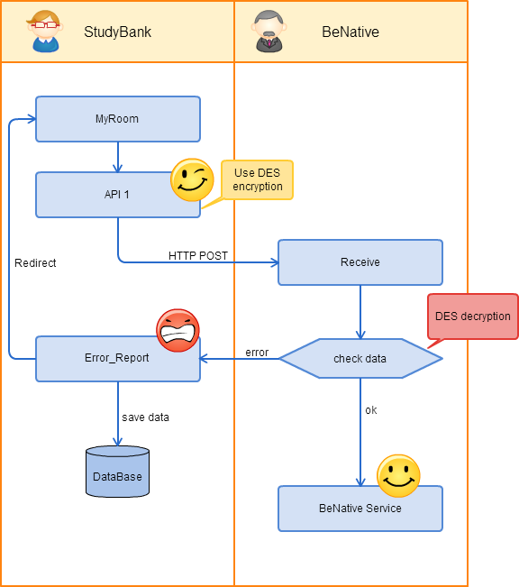

|  |  |  |  |  |  |  |
| --- | --- | --- | --- | --- | --- | --- |
| **功能** | | 合作廠商會員課程資訊串接 | | | | |
| **名稱** | | Studybank_cp_api | | | **Developer** | Anderson |
| **No.** | **項目** | | **功能主題** | **功能說明** | | **特別事項** |
| 1 | sb_cp_user_course | | 會員課程資訊串接接口 | 將SB有使用BeNative 的會員及課程資料傳送 | |  |
| 2 |  | |  |  | |  |
| 3 |  | |  |  | |  |
| 4 |  | |  |  | |  |
| 5 |  | |  |  | |  |
| 6 |  | |  |  | |  |
| 7 |  | |  |  | |  |
| 8 |  | |  |  | |  |
| 9 |  | |  |  | |  |
| 10 |  | |  |  | |  |
| 11 |  | |  |  | |  |
| 12 |  | |  |  | |  |
| 13 |  | |  |  | |  |
| 14 |  | |  |  | |  |
| 15 |  | |  |  | |  |
| 16 |  | |  |  | |  |
| 17 |  | |  |  | |  |
|  |  | |  |  | |  |
|  |  | |  |  | |  |
|  |  | |  |  | |  |
|  |  | |  |  | |  |
|  |  | |  |  | |  |
|  |  | |  |  | |  |
|  |  | |  |  | |  |
|  |  | |  |  | |  |
|  |  | |  |  | |  |
|  |  | |  |  | |  |
|  |  | |  |  | |  |
|  |  | |  |  | |  |

|  |  |  |  |  |  |  |  |  |  |  |  |
| --- | --- | --- | --- | --- | --- | --- | --- | --- | --- | --- | --- |
| **API** | | | sb_cp_user_course | | **Developer** | Anderson | | | **日期** | | 2015-05-14 |
| **功能要點** | | | 會員課程資訊串接接口 | | **URL** | http://www.studybank.com.tw/sb_api/benative_course.php | | | | | |
| **No** |  | **參數** | | **參數名稱** | | **Type** | **NULL** | **備 註** | | **E.g.** | |
| 1 |  | cmpy_code | | Company code | | String | N |  | | studybank_api | |
| 2 |  | code | | User and user’s course data, use DES encryption | | String | N | 經DES加密後字串，請見參數code內容說明表 | |  | |
| 3 |  | error_url | | Responding to Error URL | | String | N | 發生錯誤時回傳的URL | | http://www.studybank.com.tw/sb_api/error_report.php?error=cmpy_code | |

參數code內容說明表

|  |  |  |  |  |  |  |  |  |  |  |
| --- | --- | --- | --- | --- | --- | --- | --- | --- | --- | --- |
| **參數** | | code | | **加密** | DES | | | **資料格式** | | String |
| **功能要點** | | 會員課程資訊 | | **資料格式** | JSON | | | | | |
| **No** | **名稱** | | **說明** | | **Type** | **NULL** | **備 註** | | **E.g.** | |
| 1 | login_id | | User ID | | String | N |  | | [example@studybank.com.tw](mailto:example@studybank.com.tw) | |
| 2 | member_name | | User name | | String | N |  | | john | |
| 3 | course_count | | Course count | | Int | N |  | | 3 | |
| 4 | course | | Course data | | Array | N | 細節請見下表Course參數內容說明 | | {"course_code": 14120,"start_date": "2014-04-30T16:25:24Z"}, | |

course參數內容說明

|  |  |  |  |  |  |  |  |  |  |  |
| --- | --- | --- | --- | --- | --- | --- | --- | --- | --- | --- |
| **參數** | | | course | | | | | **資料格式** | | Array |
| **No** |  | **參數** | | **參數名稱** | **Type** | **NULL** | **備 註** | | **E.g.** | |
| 1 |  | course_code | | Course ID | String | N |  | | 14120 | |
| 2 |  | start_date | | Course start time | String | N |  | | 2014-04-30T16:25:24Z | |
|  |  |  | |  |  |  |  | |  | |

|  |
| --- |
| **Description** |
| **說明**  **code採DES** **(Data Encryption Standard)加密，串接方可以相對應方式解密** |

錯誤狀況

|  |  |
| --- | --- |
| **狀況1** | **廠商代碼錯誤** |
| **關鍵參數** | company_code |
| **輸出資料內容** | company_code |
| **範例說明** | company_code應為’studybank_api’，卻送出’studybook_api’，應導回http://www.studybank.com.tw/sb_api/error_report.php?error=company_code&cmpy=benative。 |
| **備註** |  |

|  |  |
| --- | --- |
| **狀況2** | **課程資訊錯誤** |
| **關鍵參數** | code |
| **輸出資料內容** | course_code_error |
| **範例說明** | code內的資料經解碼後，內容中course項目帶的課程資訊course_code與BeNative端設定的課程編號不相符，應導回http://www.studybank.com.tw/sb_api/error_report.php?error=course_code_error&cmpy=benative。 |
| **備註** | 其他課程資訊錯誤可對應此狀況 |